Code for checking if String is equal to a Palindrome:

**public** **void** palindrome(String newData){

String palindrome;

System.***out***.println("Enter a String: ");

palindrome = keyboard.nextLine();

palindrome = palindrome.replaceAll("[^a-zA-Z]+","" );

newData = palindrome;

**for**(**char** i = 0; i < newData.length(); i++){

**char** c = newData.charAt(i);

String string1 = String.*valueOf*(c);

addAtHead(string1);

}

// Comparing starts below

**for**( **char** i = 0; i < newData.length(); i++){

**char** c = newData.charAt(i);

String string1 = String.*valueOf*(c);

**if**(string1.equalsIgnoreCase(head.getData())){

deleteAtHead();

**if**(head == **null**){

System.***out***.println("The String entered is a palindrome!\n");

}

}**else** {

System.***out***.println("This string is not a palindrome\n");

**break**;

}

}

}

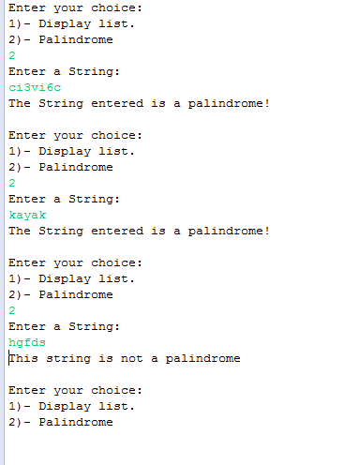

Done by: Dervon Jn Pierre

Student#: 040834987